http://themusic.com.au/news/all/2016/05/16/art-of-music-2016-collection-inspired-by-courtney-barnett-midnight-oil-and-more/

MUSIC > NEWS

Art Of Music 2016 Collection Inspired By Courtney Barnett, Midnight Oil & More
May 16th 2016 | 11:35am | Staff Writer
More Sharing Services

One of Sydney's most unique fundraising events, Art Of Music, has unveiled its 2016 collection of artists and performers to feature at the anticipated exhibition in June.
Every two years, a bevy of prominent contemporary Australian visual artists each choose a piece of music to inspire an original artwork, culminating in the Art of Music Charity Auction and Gala Dinner. This year's event will host Bernard Fanning and Stan Yarramunua, with one more performer to be announced soon.
In 2016, the 10 featured artists are Lucy Culliton, Nicholas Harding, Laura Jones, Guy Maestri, Tim Macguire, Michael Muir, Joan Ross, Alex Seton, Christian Thompson and Stan Yarramunua, with acclaimed artist Ben Quilty being freshly announced among the ranks with a painting of Jenny Morris. Featured songs include Dead Fox by Courtney Barnett,Break In The Weather by Jenny Morris and You Are My Sister by Antony & The Johnsons.
The artworks delivered so far are an impressive preview of upcoming exhibition — with the pastel beachside scenery of The Cruel Sea's Orleans Stomp by Michael Muir, a glisteningly ethereal interpretation of Sarah Blasko's Fool by Joan Ross, and a literal dead fox by Guy Maestri. See a selection of the musical depictions below.
Dead Fox by Courtney Barnett, Guy Maestri
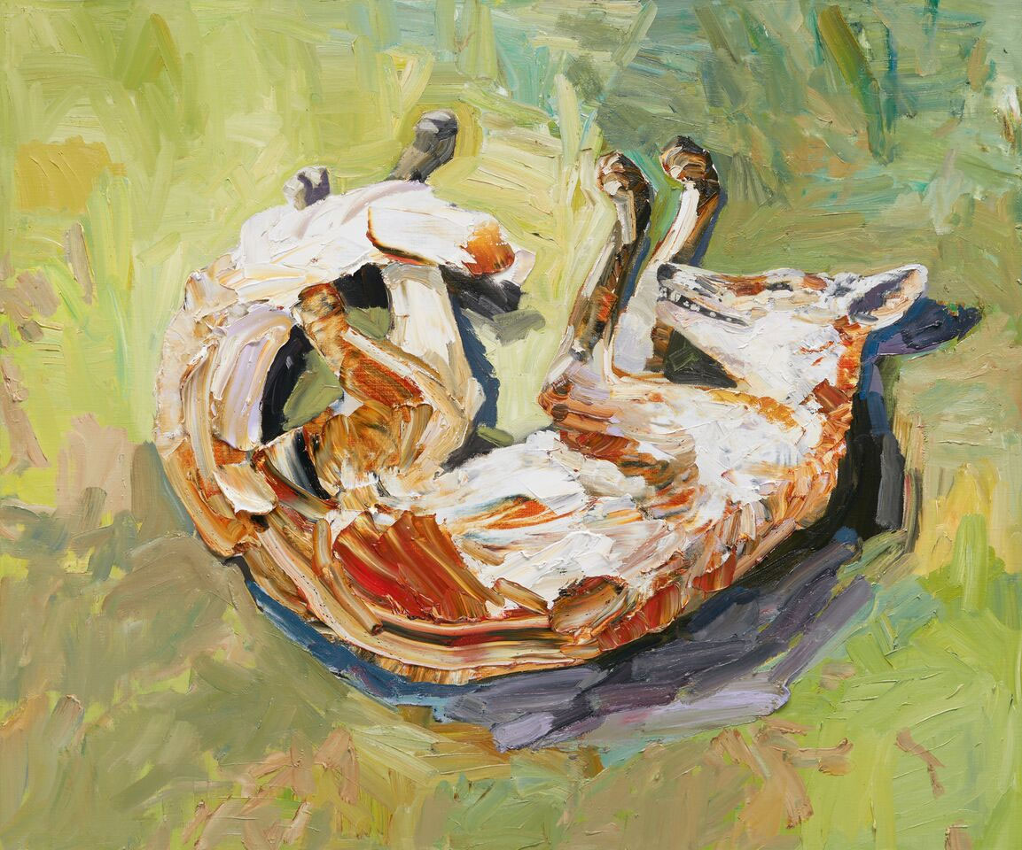
Fool by Sarah Blasko, Joan Ross
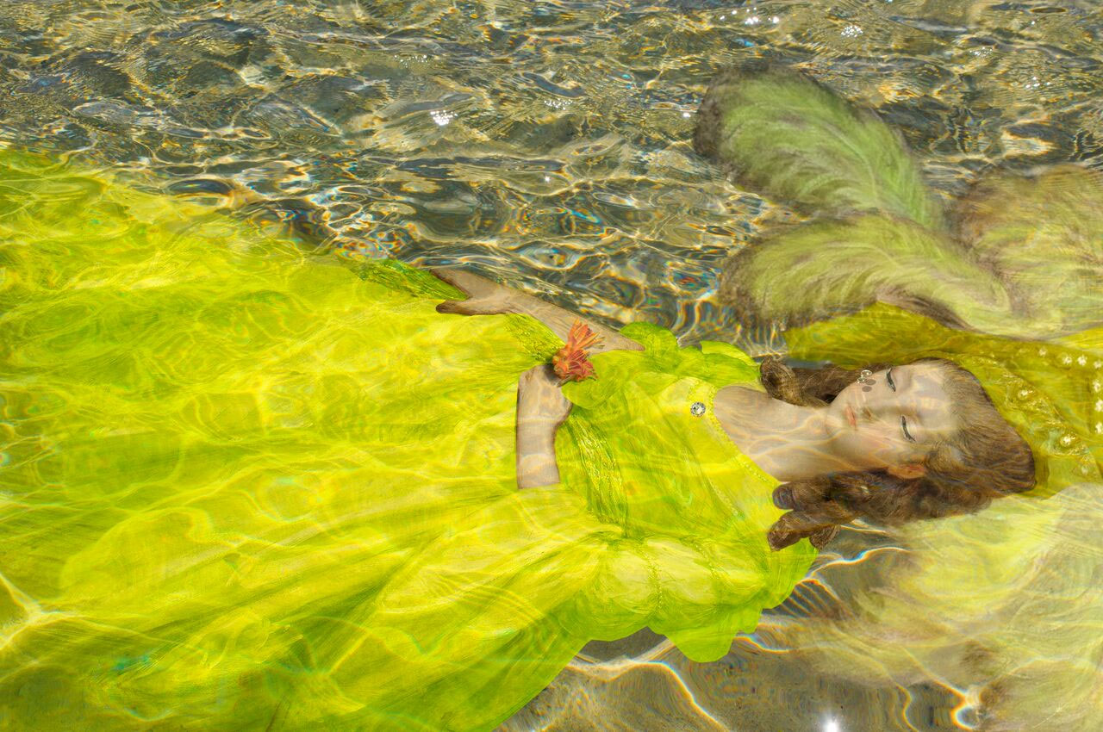
How Much Does Your Love Cost? by Thelma Plum, Laura Jones
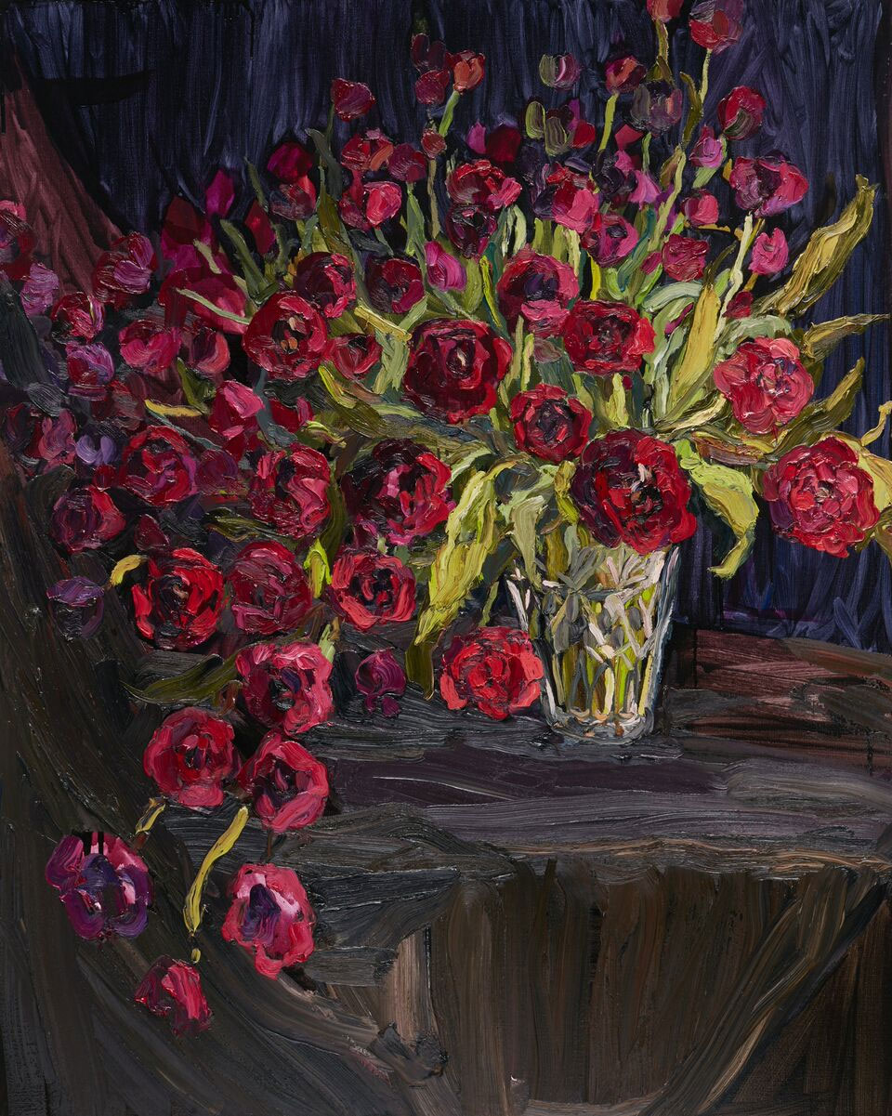
Pony by Kasey Chambers, Lucy Culliton
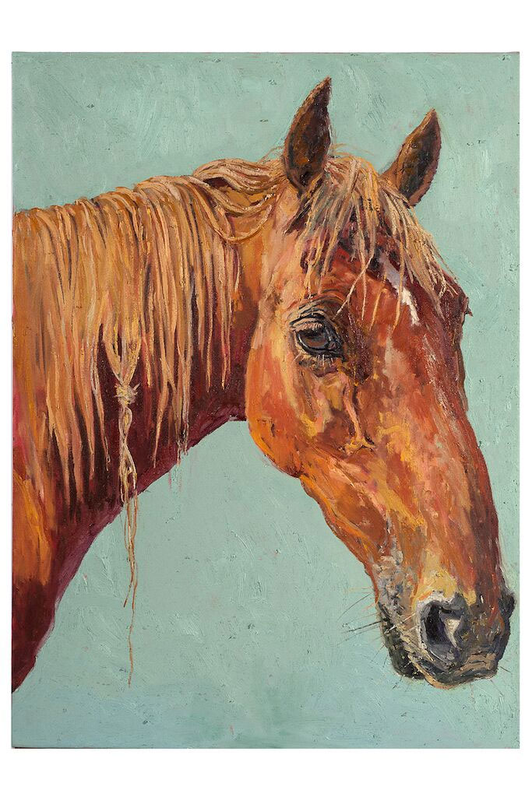
Orleans Stomp by The Cruel Sea, Michael Muir
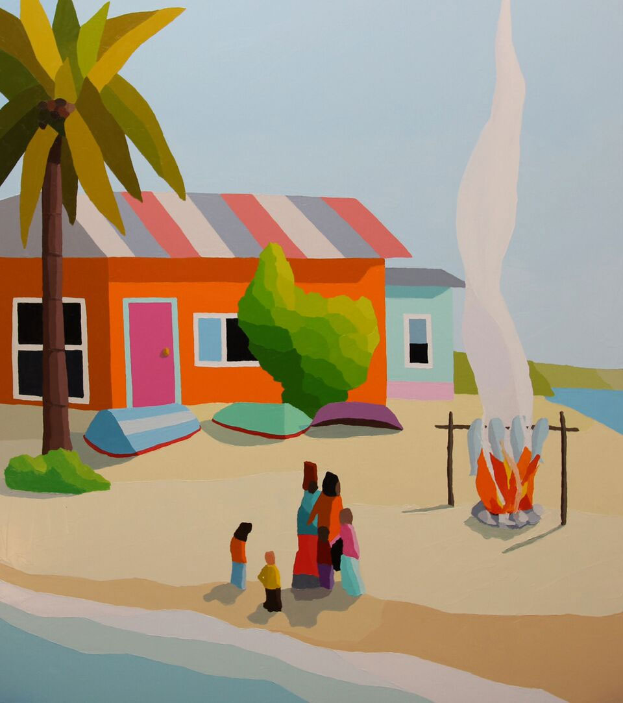
Surfing with a Spoon by Midnight Oil, Nicholas Harding
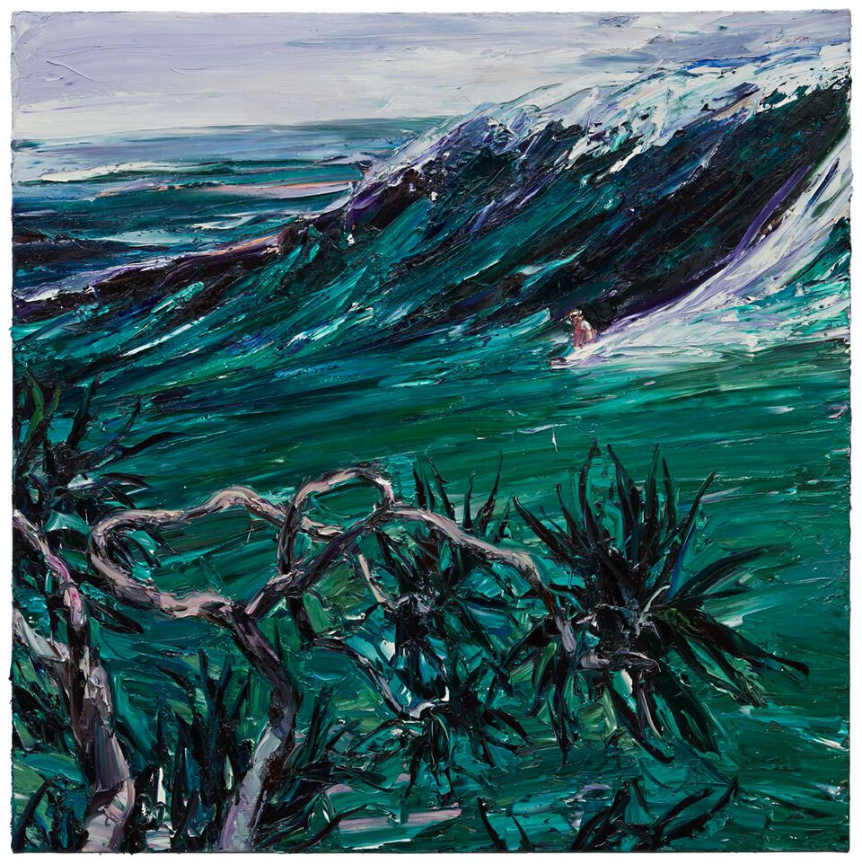
In addition to the bidding opportunities for the artworks themselves, Art Of Music will be running a raffle for a bunch of great prizes, including a bona fide Prada Galleria Saffiano handbag worth almost $3000.
All proceeds from the event go to Nordoff-Robbins Music Therapy. The facility uses registered music therapists to help people cope with the struggles of living with a wide range of needs — including children and adults with physical and intellectual disabilities, autism, trauma, illness, dementia, behaviour disorders and learning difficulties.
Tickets to the event, held on 18 June at the Art Gallery of New South Wales from 6.30pm, are available now.

